JAVA PROGRAMS

Submitted by,

Tamilvanan B.

2018503566.

MO Batch.

12-06-2020.

1.Write a servlet program that displays the protocol name, host details, current system date, and time.

Program

import java.util.Date;

import java.io.IOException;

import java.io.PrintWriter;

import javax.servlet.ServletException;

import javax.servlet.http.HttpServlet;

import javax.servlet.http.HttpServletRequest;

import javax.servlet.http.HttpServletResponse;

public class protocolName extends HttpServlet {

protected void processRequest(HttpServletRequest request, HttpServletResponse response)throws ServletException, IOException {

response.setContentType("text/html;charset=UTF-8");

try ( PrintWriter out = response.getWriter()) {

Date nowDate = new Date();

out.println("<!DOCTYPE html>");

out.println("<html>");

out.println("<head>");

out.println("<title>Display Information</title>");

out.println("</head>");

out.println("<body style = 'font-family : Roboto; font-size : 20px;'>");

out.println("<p>Protocol Name : <span style = 'color : blue'>" + request.getScheme() + "</span></p>");

out.println("<p>Current Date and Time : <span style = 'color : blue'>" + nowDate.toString() + "</span></p>");

out.println("<p>Client Info : <span style = 'color : blue'>" + request.getHeader("User-Agent") + "</span></p>");

out.println("<p>Server Info : <span style = 'color : blue'>" + getServletContext().getServerInfo() + "</span></p>");

out.println("</body>");

out.println("</html>");

}

}

@Override

protected void doGet(HttpServletRequest request, HttpServletResponse response) throws ServletException, IOException {

processRequest(request, response);

}

@Override

protected void doPost(HttpServletRequest request, HttpServletResponse response) throws ServletException, IOException {

processRequest(request, response);

}

@Override

public String getServletInfo() {

return "Short description";

}

}

Output

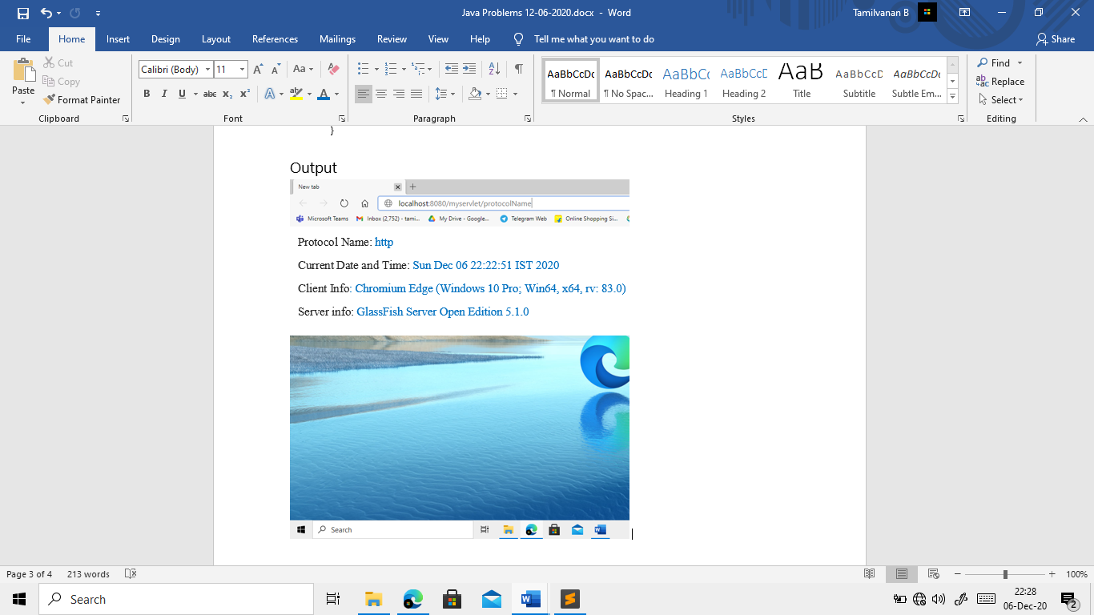

2.Design a web application using HTTP servlet that accepts user login information and welcomes the particular user by displaying the user name and the date of current session.

Program

import java.util.Date;

import java.io.IOException;

import java.io.PrintWriter;

import java.time.LocalDate;

import java.time.LocalDateTime;

import javax.servlet.ServletException;

import javax.servlet.http.HttpServlet;

import javax.servlet.http.HttpServletRequest;

import javax.servlet.http.HttpServletResponse;

public class Login extends HttpServlet {

static String[] username = {"Java", "java123"};

static String[] password = {"passwrd", "123"};

protected void processRequest(HttpServletRequest request, HttpServletResponse response) throws ServletException, IOException {

response.setContentType("text/html;charset=UTF-8");

try ( PrintWriter out = response.getWriter()) {

out.println("<!DOCTYPE html>");

out.println("<html>");

out.println("<head>");

out.println("<title>Servlet Login</title>");

out.println("</head>");

out.println("<body>");

out.println("<h1>Servlet Login at " + request.getContextPath() + "</h1>");

out.println("</body>");

out.println("</html>");

}

}

protected void showLoginForm(HttpServletRequest request, HttpServletResponse response) throws IOException, ServletException{

response.setContentType("text/HTML");

try(PrintWriter out = response.getWriter()){

out.write("<html>");

out.write("<title>Login</title>");

out.write("<body style = 'padding : 100px; font-size : 20px; font-family : Roboto;'>");

out.write("<form method = 'post'>");

out.write("<label>Username : <input type = 'text' name = 'username'/></label><br>");

out.write("<label>Password : <input type = 'password' name = 'password'/></label><br>");

out.write("<input type = 'submit' id = 'login' value = 'Login' />");

out.write("</form>");

out.write("</body>");

out.write("</html>");

}

}

protected void showOutput(HttpServletResponse response, boolean logged, int index) throws IOException, ServletException{

try(PrintWriter out = response.getWriter()){

LocalDate today = LocalDate.now();

out.write("<html>");

out.write("<body style = 'padding : 100px; font-size : 20px; font-family : Roboto;'>");

if(logged)

out.write("<p>Successfully Logged in! Welcome " + Login.username[index] + " Today's Date : " + today.toString() + "</p>");

else

out.write("<p>Login Unsuccessful! Please Reload and Login again!</p>");

out.write("</body>");

out.write("</html>");

}

}

protected void LoginAuthentication(HttpServletRequest request, HttpServletResponse response) throws IOException, ServletException{

String uString = request.getParameter("username");

String pString = request.getParameter("password");

boolean found = false;

int ans = -1;

//Search our Database for username and password

for(int i = 0;i < Login.username.length; i++){

if(uString.equals(Login.username[i]) && pString.equals(Login.password[i])){

found = true;

ans = i;

break;

}

}

showOutput(response, found, ans);

}

@Override

protected void doGet(HttpServletRequest request, HttpServletResponse response)throws ServletException, IOException {

showLoginForm(request, response);

}

@Override

protected void doPost(HttpServletRequest request, HttpServletResponse response) throws IOException, ServletException{

LoginAuthentication(request, response);

}

@Override

public String getServletInfo() {

return "Short description";

}

}

Output

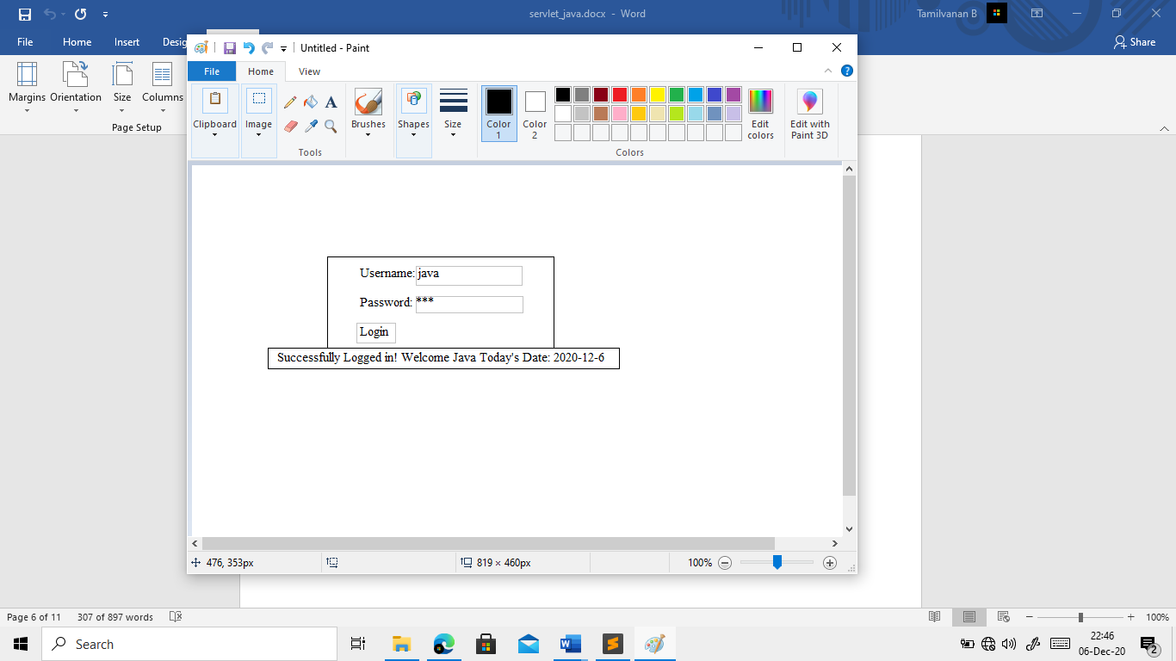

3. Implement a server-side java program using servlet. The program should allow a user to enter the feedback form for an employee. Once submitted the servlet should write the form data to a file and responds to the user with thank you message.

Program

import java.io.\*;

import java.io.IOException;

import java.io.PrintWriter;

import javax.servlet.ServletException;

import javax.servlet.http.HttpServlet;

import javax.servlet.http.HttpServletRequest;

import javax.servlet.http.HttpServletResponse;

public class Feedback extends HttpServlet {

static String[] employees = {"cpp", "java", "scharp", "python"};

static int recordNo = 1;

static String filename = "D:\\Temp\\feedback.txt";

static File f = new File(filename);

protected void showFeedbackForm(HttpServletRequest request, HttpServletResponse response)throws ServletException, IOException {

response.setContentType("text/html;charset=UTF-8");

try ( PrintWriter out = response.getWriter()) {

out.println("<!DOCTYPE html>");

out.println("<html>");

out.println("<head>");

out.println("<title>User Feedback</title>");

out.println("</head>");

out.println("<body style = 'padding : 100px; font-size : 20px; font-family : Roboto;'>");

out.println("<form method = 'post'>");

out.println("<label>Enter your name : <input type = 'text' name = 'name' required></label><br><br>");

out.println("<label>Choose Employee to give Feedback : <select name = 'EmpName'>");

for(int i = 0; i < Feedback.employees.length; i++){

out.println("<option value = '"+ i +"'>" + Feedback.employees[i] + "</option>");

}

out.println("</select></label>");

out.println("<p>Rate your experience : </p>");

for(int i = 1; i <= 5; i++){

out.println("<input type = 'radio' name = 'stars' value = '" + i + "' required/><label for = '" + i + "'>");

for(int j = 0; j < i ; j++)

out.println("★");

out.println("</label><br>");

}

out.println("<br><p>Any other suggestions : </p>");

out.println("<input type = 'text' name = 'suggestions' height = '50' width = '50' />");

out.println("<br><br><input type = 'submit' value = 'Submit Feedback' />");

out.println("</form>");

out.println("</body>");

out.println("</html>");

}

}

@Override

protected void doGet(HttpServletRequest request, HttpServletResponse response)throws ServletException, IOException {

showFeedbackForm(request, response);

}

protected void processRequest(HttpServletRequest request, HttpServletResponse response) throws IOException, ServletException{

String name = request.getParameter("name");

String EmpName = request.getParameter("EmpName");

String stars = request.getParameter("stars");

String suggestions = request.getParameter("suggestions");

FileWriter fout = new FileWriter(f, true);

fout.write("[ RECORD : " + recordNo + " ]\n");

fout.write("Name : " + name + "\n");

fout.write("Employee Name : " + EmpName + "\n");

fout.write("Stars : " + stars + "\n");

fout.write("Further Suggestions : " + suggestions + "\n");

recordNo++;

fout.close();

PrintWriter out = response.getWriter();

out.print("<h1>THANK YOU for your feedback " + name +" !</h1>");

}

@Override

protected void doPost(HttpServletRequest request, HttpServletResponse response)throws ServletException, IOException {

processRequest(request, response);

}

@Override

public String getServletInfo() {

return "Short description";

}

}

Output

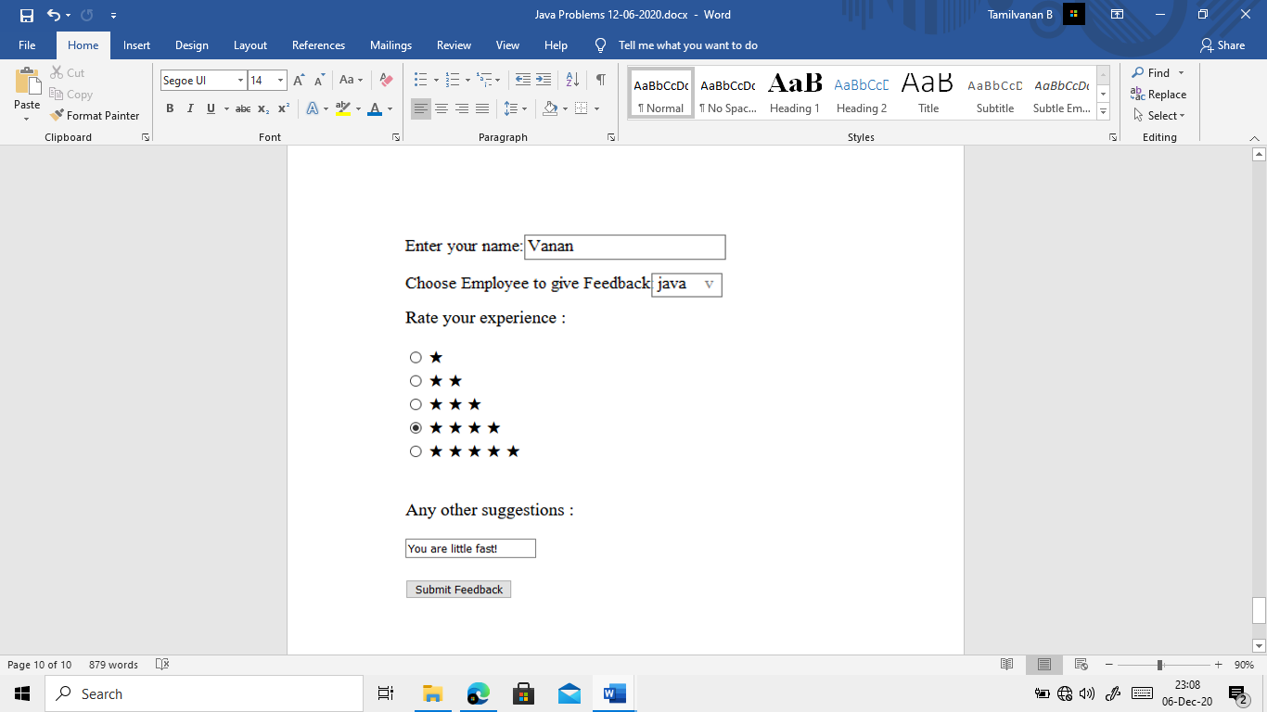

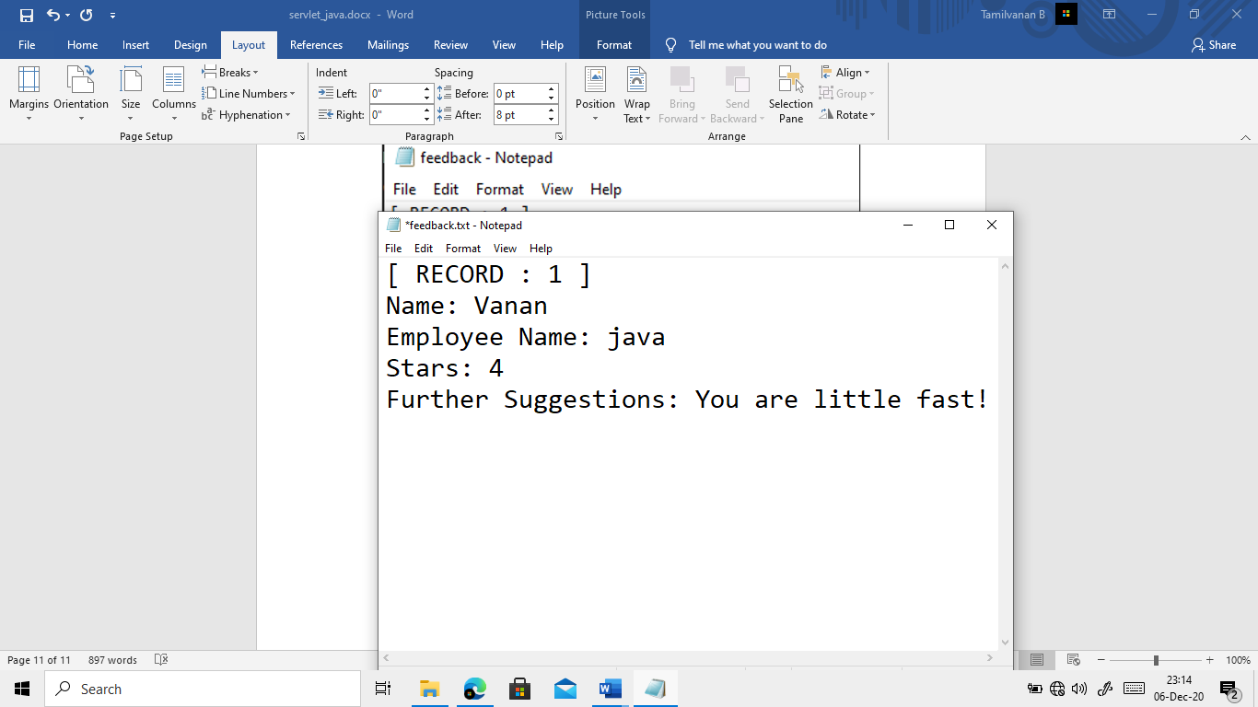

THANK YOU for your feedback Vanan